Table Clock with REM Sleep Monitor

* There are two basic types of sleep: rapid eye movement(REM) sleep and non-REM sleep(3 different stages).
* REM sleep is important to your sleep cycle because it stimulates the areas of your brain that are essential in learning and making or retaining memories.
* REM sleep is characterized by motionlessness during sleep, and this paralysis during sleep is what we monitor in our project.

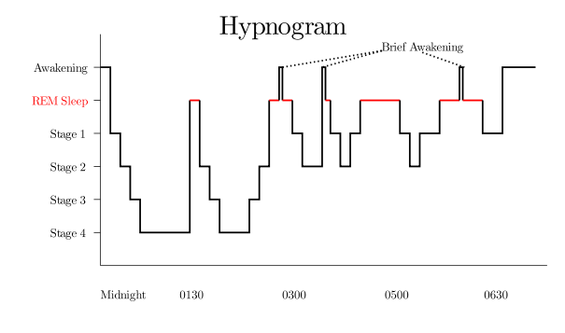 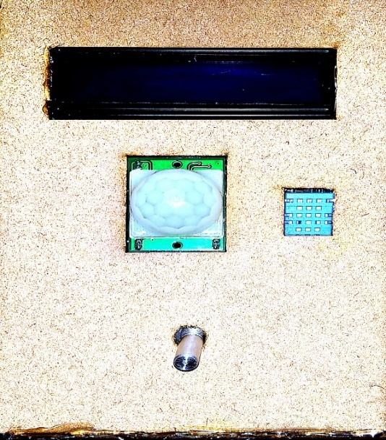

Our Idea CLOCK FACE

* The table clock has a LCD monitor which continuously shows time, date, day, room temperature and humidity.
* We use PIR motion sensor to detect motion during sleep, so if you are in REM sleep (you lay motionless), the RTC module shall record the duration for which you are motionless, and also during this time duration the temperature and humidity sensor will record the values of temp and humidity.
* After you wake up in the morning, you have to turn the knob anticlockwise and monitoring will stop. Afterwards you can view the time duration, temperature and humidity values using the app, which receives data using the Bluetooth module through Arduino.
* You can also keep track of time durations and corresponding temp and humidity values of previous days by pressing the show history button and therefore can fine tune your room’s conditions to get more REM sleep during the night.

GitHub Link: https://github.com/Chokerino/Sleep-Monitor